Cool T-Shirts Website Funnel Analysis
Extended R / dplyr project • Joining Tables + Funnel Metrics + Simulation

Problem Statement
Cool T-Shirts Inc. tracks website activity in three separate tables (visits, checkouts, purchases) that share a user_id key. Leadership needs a clear picture of the conversion funnel: how many visitors reach checkout, how many complete a purchase, the average time between stages, and where the largest drop-offs occur. The data must be joined correctly so that conversion rates are calculated from the proper denominators, and results must be communicated differently to analysts versus executives.

Solution Strategy
1. Load the three CSVs with readr and inspect schema/row counts. 2. Inner-join visits ⨝ checkouts to obtain the set of users who reached checkout and compute time-to-checkout. 3. Left-join the full visit base to both later tables so non-converters are retained for rate calculation. 4. Derive stage counts, visit→checkout, checkout→purchase and overall conversion rates. 5. Visualise the absolute funnel and the time distribution. 6. Provide alternate base::merge / full_join diagnostics, monthly breakdowns, and a parameterised Monte-Carlo simulation that lets stakeholders explore sensitivity to conversion probabilities and time noise. 7. Package insights with audience-adapted messaging (analyst vs executive).

Solution
Key results with the supplied synthetic cohort (n = 250 visits):
• Visits: 250 • Checkouts: 100 (40.0 %) • Purchases: 25 (10.0 % overall)
• Checkout → Purchase conversion = 25 %
• Mean time visit → checkout ≈ 37.0 hours (median ≈ 39.2 h)
The largest absolute drop-off is between visit and checkout (150 users / 60 %). Improving the path from product page to cart is therefore higher-leverage than optimising the final payment step.
Stage | Count | Conv. from previous
Visits | 250 | —
Checkouts | 100 | 40.0 %
Purchases | 25 | 25.0 %
Process flowchart (see also notebooks):
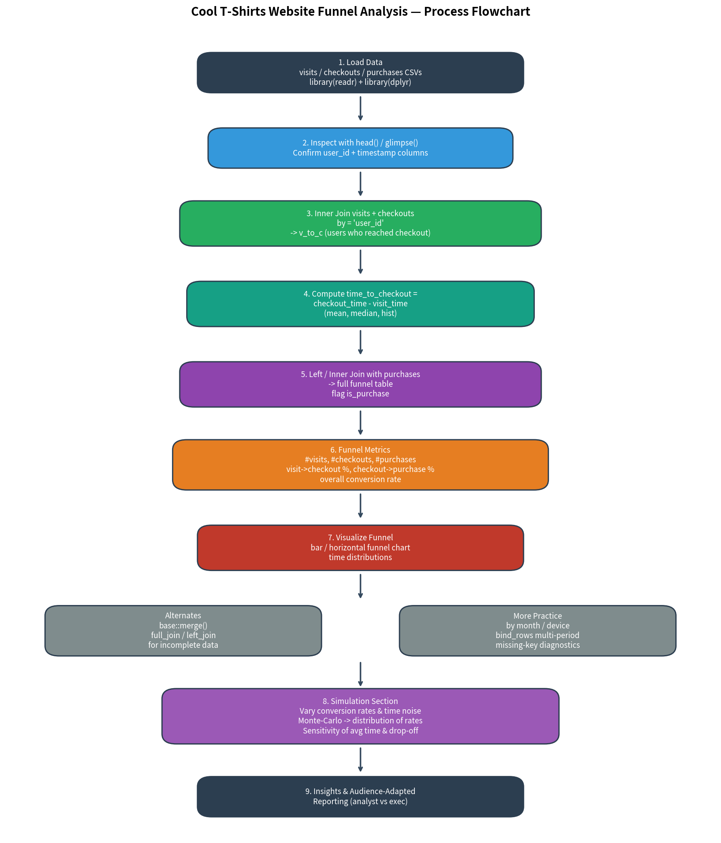

Key Takeaways
• Join choice matters: inner_join for “who did both events”; left_join from the visit base when rates need the full denominator.
• Biggest leak: visit → checkout (60 % drop). Product and UX work on the early funnel is the priority.
• Time metric: average ~1.5 days to reach checkout; useful for SLA / retargeting windows.
• Simulation: Monte-Carlo with adjustable p_checkout / p_purchase quickly shows how sensitive headline rates are to small lifts.
• Audience: Analysts receive full code + diagnostics; executives receive the 1-page rates + one recommendation; nonspecialists receive plain-language “out of 100 visitors…” framing.
Files: Cool_TShirts_Funnel_Practice_Skeleton.ipynb • Cool_TShirts_Funnel_Solution.ipynb • data/*.csv • flowchart.png • Cheatsheet / Strategy Guide / Memo

